**EC60064: Biomedical System Engineering and Automation**

**Experiment 1**

1. The data file *data_ecg_noisy.mat* contains ECG signal, sampled at 360Hz, with a significant amount of 60Hz power-line artifact.
   1. Design a **notch filter** with two zeros to remove the artifact and implement it in Python.
   2. Add two poles at same frequency as those of zeros, but with a radius that is less than unity. Study the effect of poles on output of the filter as their radius is varied from 0.8 to 0.99.

Theory/Procedure: ${∠z}_{1},{ ∠p}_{1} =2π\frac{f_{0}}{f_{s}}=\frac{π}{3}, {∠z}_{2},{ ∠p}_{2}=-2π\frac{f_{0}}{f_{s}}=-\frac{π}{3}$

${ |z}_{1}\left|={|z}_{2}\right|=1,{ |p}_{1}\left|={|p}_{2}\right|=r$

$a. H\left(z\right)=\left(1-z_{1}z^{-1}\right)\left(1-z_{2}z^{-1}\right)= 1-z^{-1}+z^{-2}$

$b. H\left(z\right)=\frac{\left(1-z_{1}z^{-1}\right)\left(1-z_{2}z^{-1}\right)}{\left(1-p_{1}z^{-1}\right)\left(1-p_{2}z^{-1}\right)}= \frac{1-z^{-1}+z^{-2}}{1-{rz}^{-1}+r^{2}z^{-2}}$

Results:

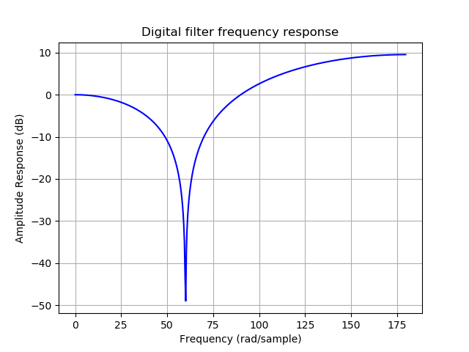a.

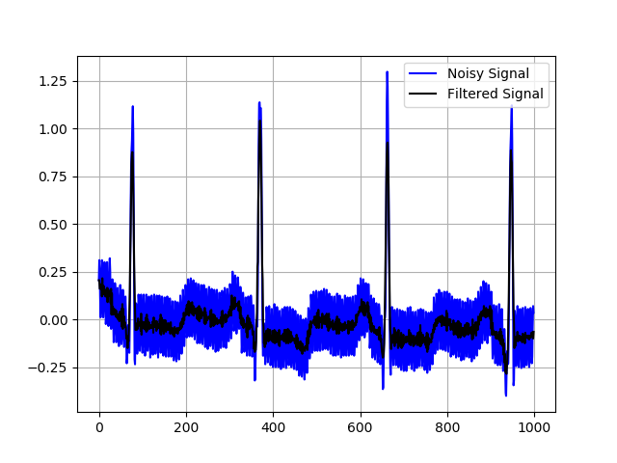

b.

r = 0.8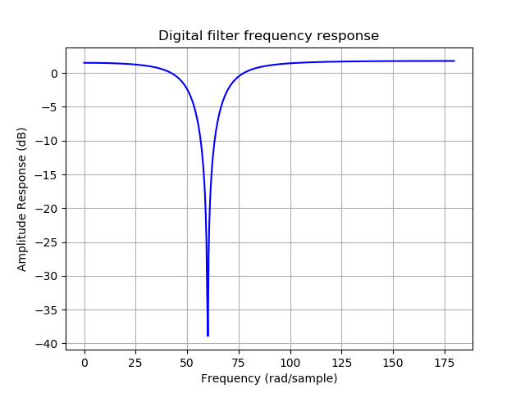

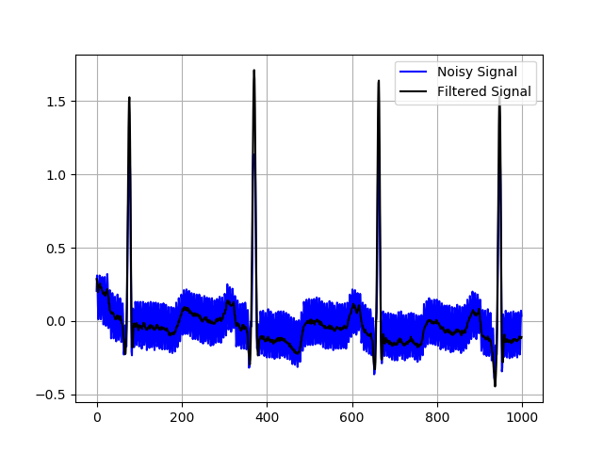r = 0.99

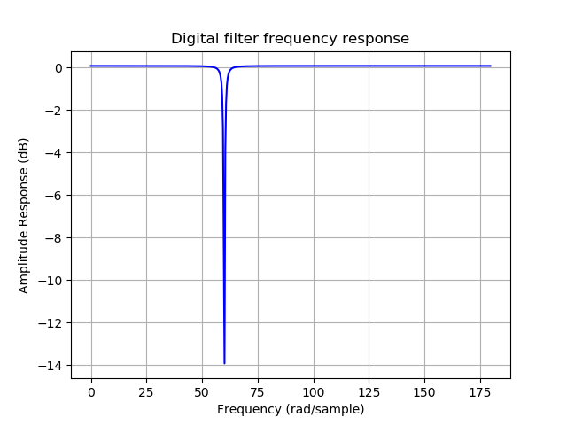

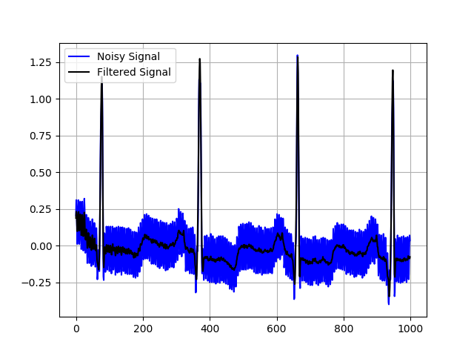

Discussions: On adding poles the notch filter becomes sharper.

1. A ECG signal (sampled at 360Hz) is provided in the file *data_ecg_original.mat*. Add white Gaussian noise (WGN) to the signal at Signal-to-Noise Ratio (SNR) = 0 dB to obtain *ecg_noisy_wgn.mat*. Develop a Python code to perform **Synchronized averaging**. Select a QRS complex from the noisy signal for use as the template and use a suitable threshold on cross-correlation function for beat detection.
2. Plot the result of averaged QRS complex. Ensure that the averaged result covers one full cardiac cycle. Plot a sample ECG cycle each from noisy and original signals for comparison.
3. What is the theoretical improvement in SNR?
4. Compute and plot how the improvement in SNR varies with the number of beats used for averaging. Does this match with the theoretical value for improvement in SNR?
5. Repeat the experiments (a) to (c) with ECG in *data_ecg_original.mat* and power line interference noise at 60 Hz and comment. (*Hint:* For the powerline noise, generate a 60 Hz sinusoid signal sampled at 360 Hz of duration the same as the signal.)

Theory/Procedure: $\frac{1}{N}\sum{y}=\frac{1}{N}\sum{x}+\frac{1}{N}\sum{n}$

$∆SNR\left(dB\right)=10\log_{10}(N)$

The cross-correlation between the template and the whole data is computed and compared with a threshold. If the result is positive, then the sample is used in the averaging procedure.

Results:

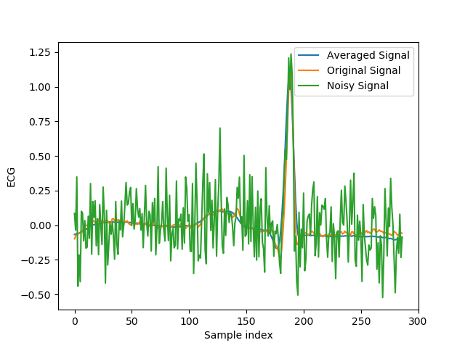a.

b. Observed improvement in SNR = 37 dB

Theoretical improvement in SNR = 41 dB (uncorrelated noise)

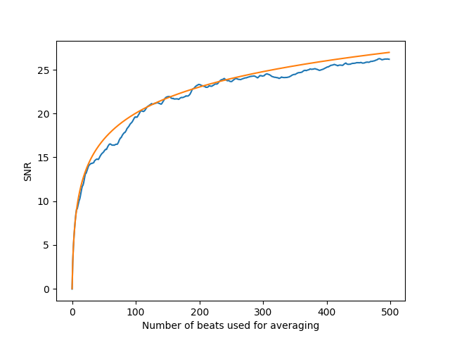c.

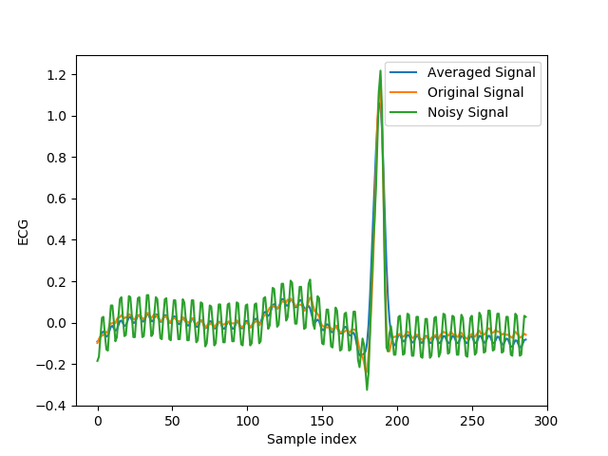 d.

Observed improvement in SNR = 13 dB

Theoretical improvement in SNR = 41 dB (uncorrelated noise)

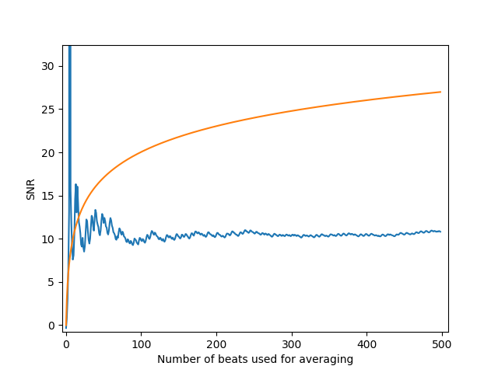

Discussions: The synchronized averaging technique works well for additive white Gaussian noise, and yields close to expected SNR improvement. However, much lower improvement is observed for power line interference. The reason for this is its periodic and highly correlated nature between samples.

1. Filter the noisy ECG signal in *ecg_noisy_wgn.mat* (in Question 2) using four different **Butterworth low pass filters** (individually) realized through Python with the following characteristics:
2. Order 2, cutoff frequency 10Hz;
3. Order 8, cutoff frequency 20Hz;
4. Order 8, cutoff frequency 40Hz;
5. Order 8, cutoff frequency 70Hz;

* 1. Compute the SNR improvement for each filter in (i) – (iv).
  2. Compare the results using each of the four Butterworth filters (individually) with those obtained by synchronized averaging, and comment on the improvement or distortions of the outputs. Relate your discussion to specific characteristics observed in plots of the signals.
  3. Filter the original ECG signal in *data_ecg_original.mat* using Butterworth filters (i) – (iv) and compute the Signal-to-Distortion Ratio (SDR) in each case.

Theory/Procedure: $∆SNR\left(dB\right)=10 \log_{10}(\frac{Power\left(h*s\right)}{Power\left(h*n\right)})$

Results:

a. i. Improvement in SNR = 9.1 dB

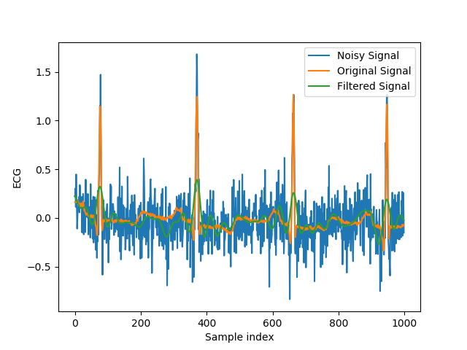

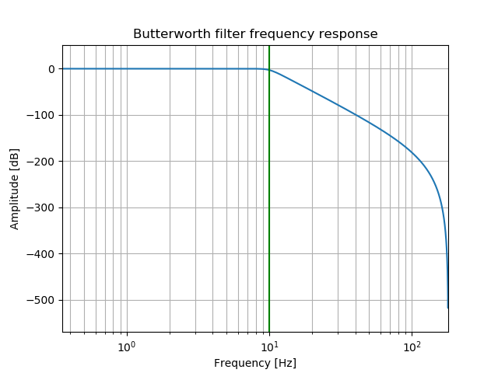

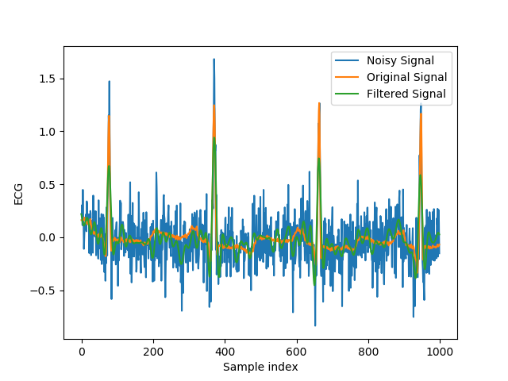ii. Improvement in SNR = 8.6 dB

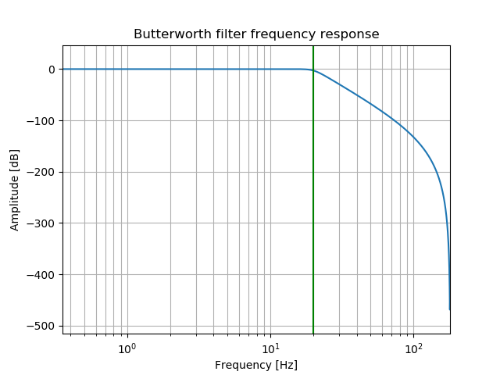

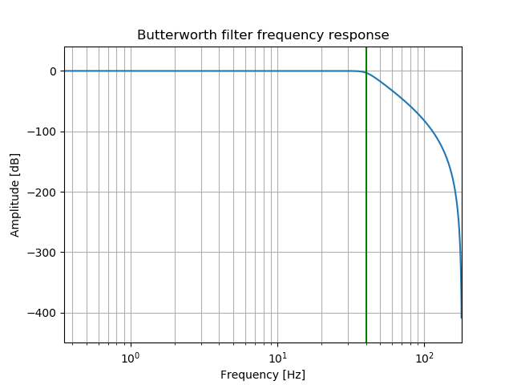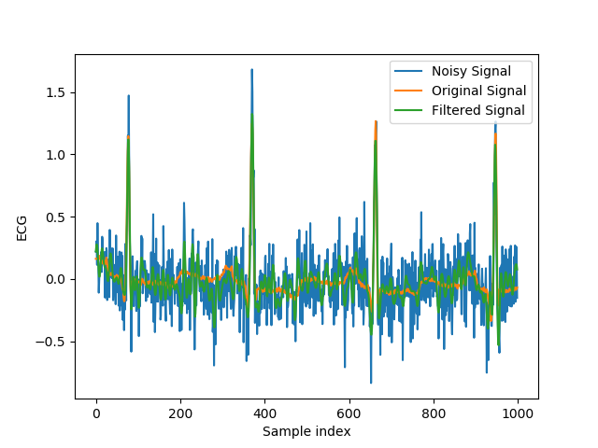iii. Improvement in SNR = 6.6 dB

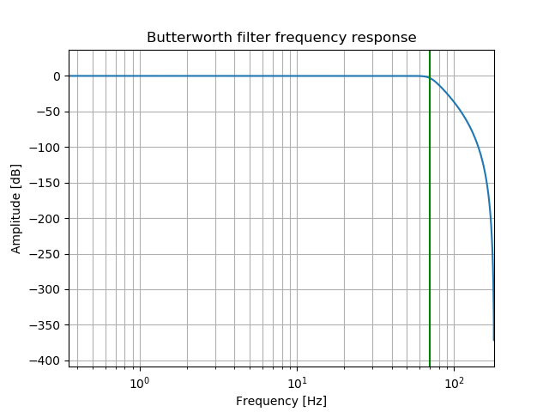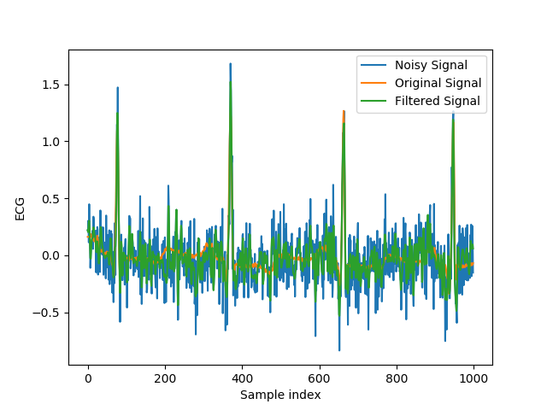iv. Improvement in SNR = 4.3 dB

b. Synchronized averaging – improvement in SNR = 37 dB

i. Improvement in SNR = 9.1 dB

Lower peak of QRS complex (1/5th) and slightly noisy PQ, STU complexes

ii. Improvement in SNR = 8.6 dB

Lower peak of QRS complex (1/3rd) and noisier PQ, STU complexes

iii. Improvement in SNR = 6.6 dB

Lower peak of QRS complex (1/2nd) and very noisy PQ, STU complexes

iv. Improvement in SNR = 4.3 dB

Same peak of QRS complex and extremely noisy PQ, STU complexes

c. i. SDR = 2.8 dB

ii. SDR = 7.6 dB

iii. SDR = 19.4 dB

iv. SDR = 31.3 dB

Discussions: Synchronized averaging seems to perform better that Butterworth low pass filtering. The main reason for this is due to the overlap in the signal and noise power spectral densities, which can’t be amended via frequency domain filtering. Hence, time-based filtering techniques, such as synchronized averaging, perform significantly better in such a scenario. Also, it is noticed that the signal to distortion ratio improves on increasing the filter cut-off frequencies. This is due to significant high frequency components in the ECG signal data set.